TASK 3

# Users & Data Security

the users involved in this project, along with the license and the profiles they are using. and also listing out the various security level utilities for the object levels and record levels are

there are 3 users in the project

* Principal
* Teacher
* Parent

1.principal

2.teacher

3. parent

The profile and license used by the users are

1. principal

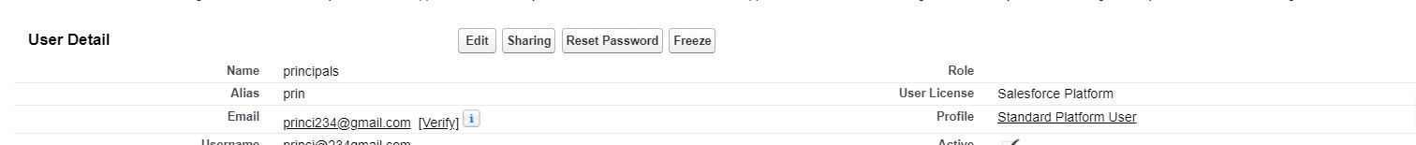

License is salesforce platform

Profile is standard platform user

2. teacher



License is salesforce platform

Profile is standard platform user

3. parent



License is salesforce

Profile is school profile

The security levels

